Case 5-Asia-Japan-Haniwa-Warrior in Armor-Kofun Period-250 to 538 CE
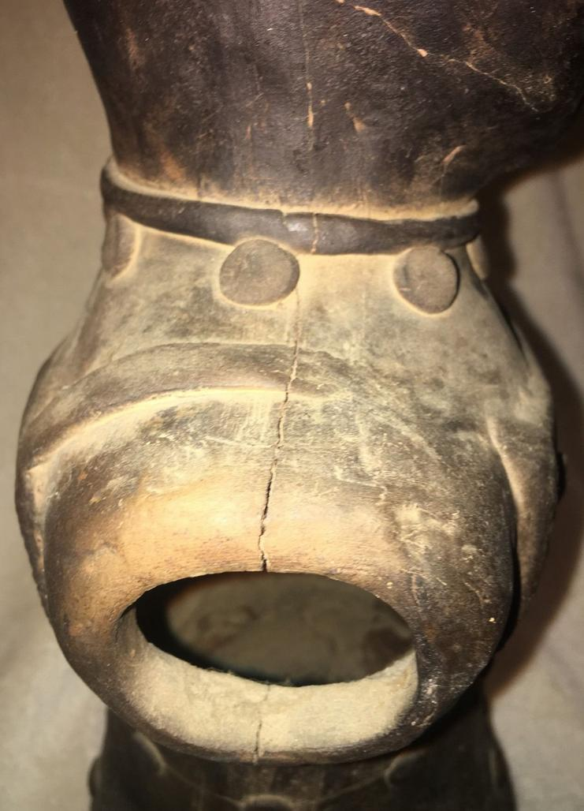
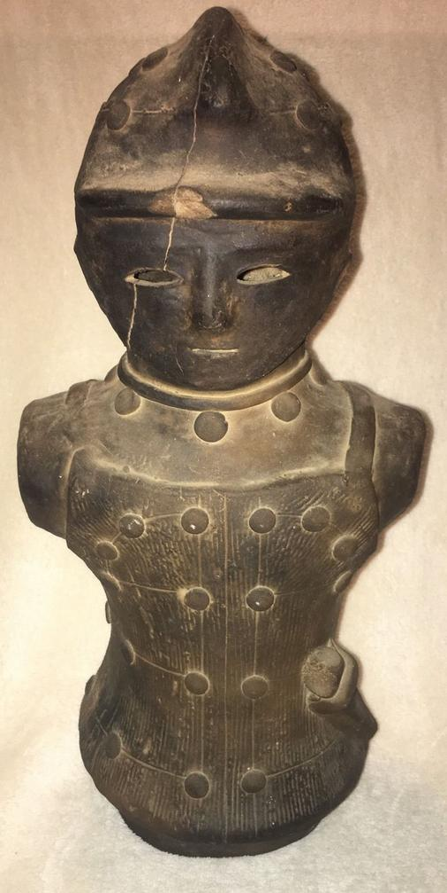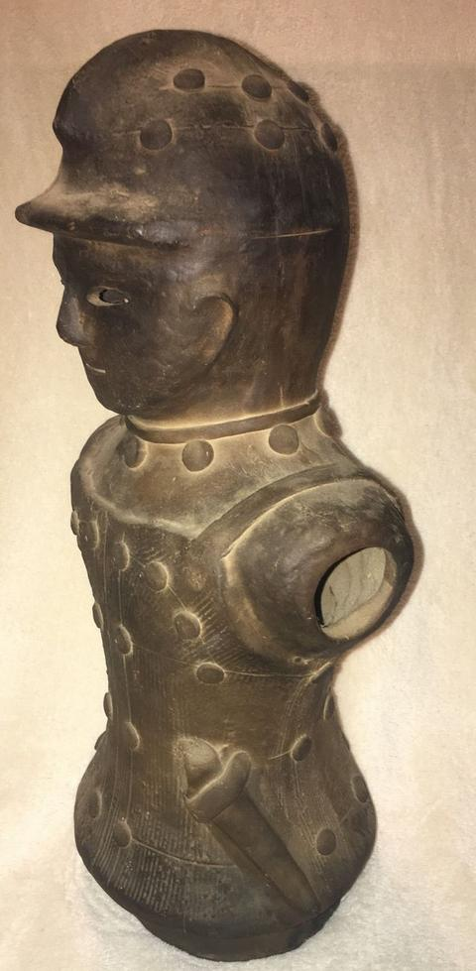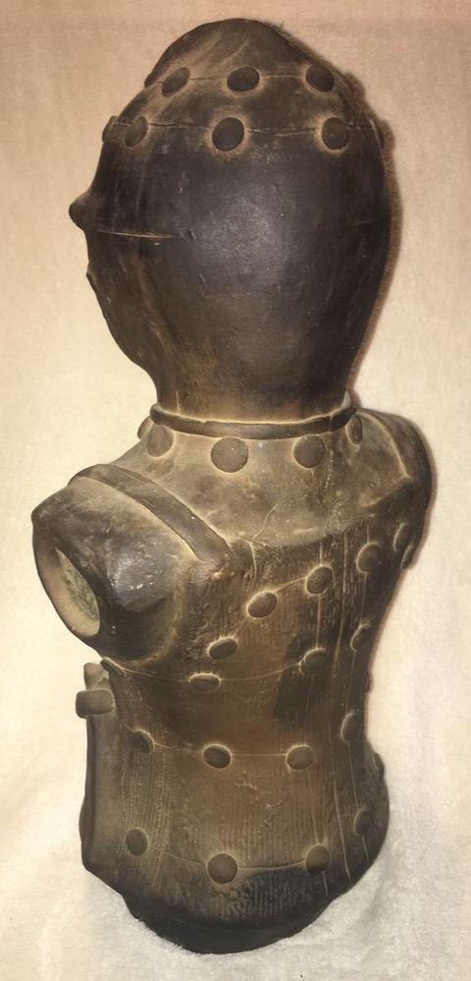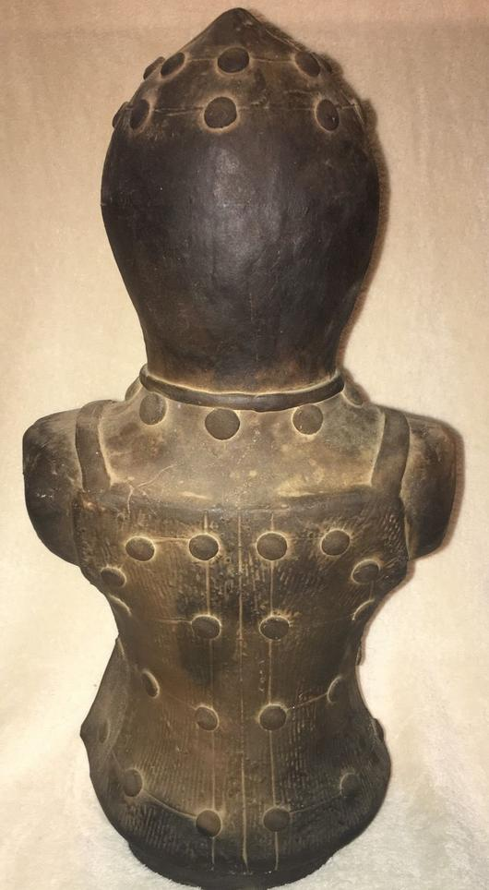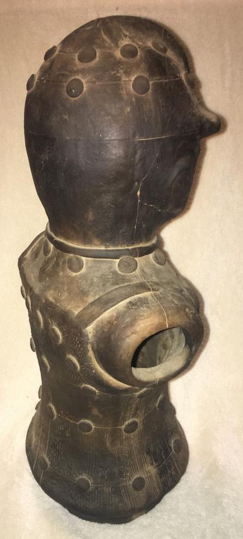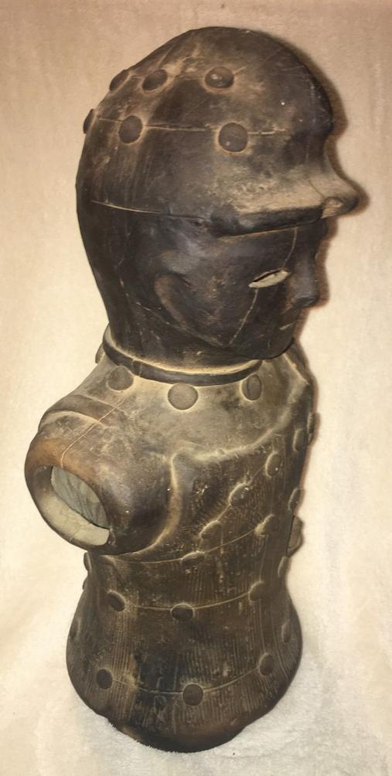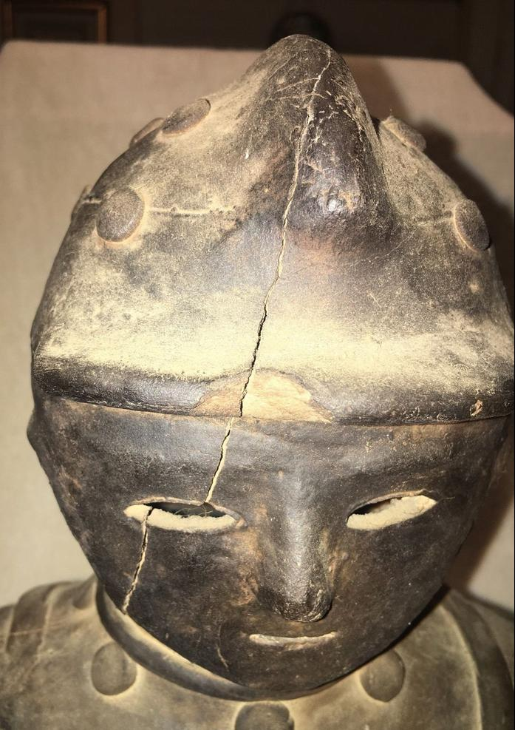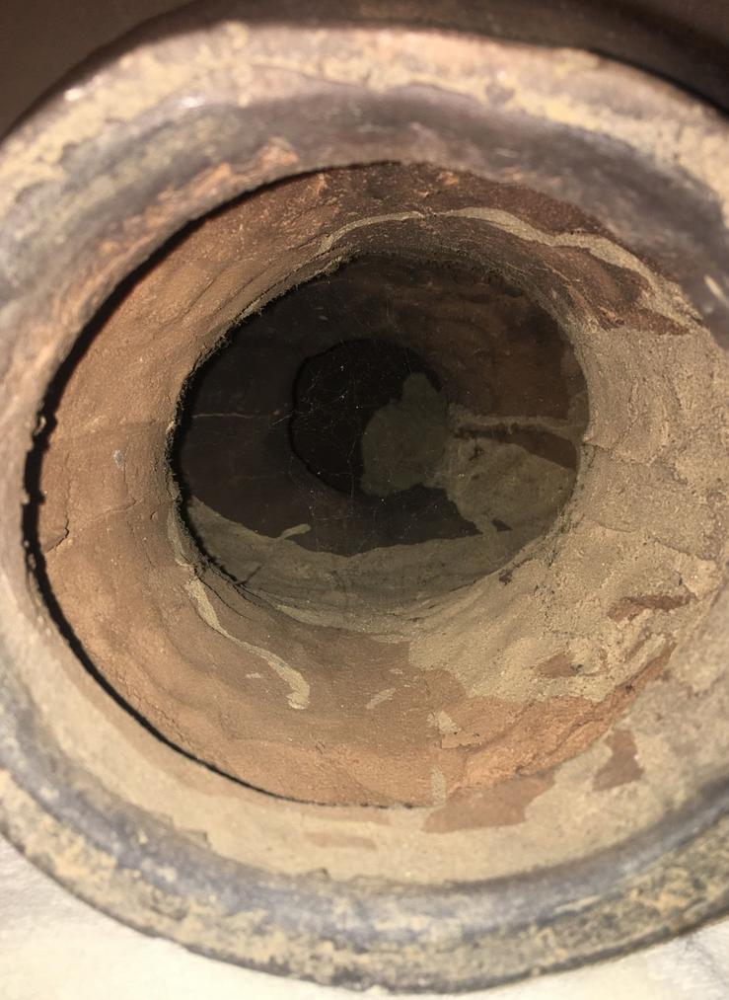
CE
Accession Number: NB 1667.A4
Date or Time Horizon: 250 to 538 CE
Geographical Area: Japan
Cultural Affiliation: Kofun Period. Early copy ca. 1900 of original from Kami Chujo Kumagai-shi, Saitama Prefecture, Kanto Region
(Miki 1961: plate 15).
Medium: Terracotta
Dimensions: 16.5 in
Weight:
Provenance: U.S. Naval Captain, Occupied Japan, 1947.
Condition: Mended cracks
Discussion: Only known figure of Haniwa warrior wearing the cuirass or corselet (tanko) armor, made of horizontal, overlapping iron strips riveted together.
References: Miki, Fumio. 1961. Haniwa : the clay sculpture of protohistoric Japan / English adaptation by Roy Andrew Miller. Rutland, Vt./ Tokyo, Japan: C.E. Tuttle, [1961]

